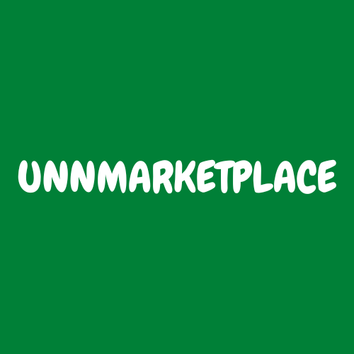

Unnmarketplace Project launch and operations

**February 15th**

Document Status: **Draft**

**Executive Summary:**

*launch an online marketplace*

|  |
| --- |
| **Project Goal** |
| * Launch online marketplace for unn community within one week. |

|  |
| --- |
| **Deliverables** |
| 1. website 2. Video contents 3. Business email 4. Business social accounts |

|  |
| --- |
| **Business Case / Background** |
| **Why are we doing this?**   * To improve interaction of businesses and their customers |

|  |
| --- |
| **Benefits, Costs, and Budget** |
| **Benefits:**   * Develop skills by practising. * Portfolio * Hands on project for participants * Pioneers of a new system   **Costs:**   * Free work of volunteer until there is light in the tunnel.   **Budget needed:**   * $10 (negligible) |

|  |
| --- |
| **Scope and Exclusion** |
| **In-Scope:**   * Customer service standards, delivery processes, training protocols * Create workspace * Advertisement * Continous marketing   **Out-of-Scope:**   * Not doing the above is out of scope |

|  |
| --- |
| **Project Team** |
| **Project Sponsor:** Truth (project manager and founder)  **Project Lead:** Project Manager (Me!)  **Project Team:** social media Manager, customer success rep, video editor, content creator, digital marketer  **Additional Stakeholders:** Investors, corporate vendors, influencer. |

|  |
| --- |
| **Measuring Success** |
| **What is acceptable:**   1. Have 25 vendors sign up an list their products before the end of January |